1. POST resource means the post by users on the Blog App.
2. In this lecture, we will see how to design API for POST Resource.
3. 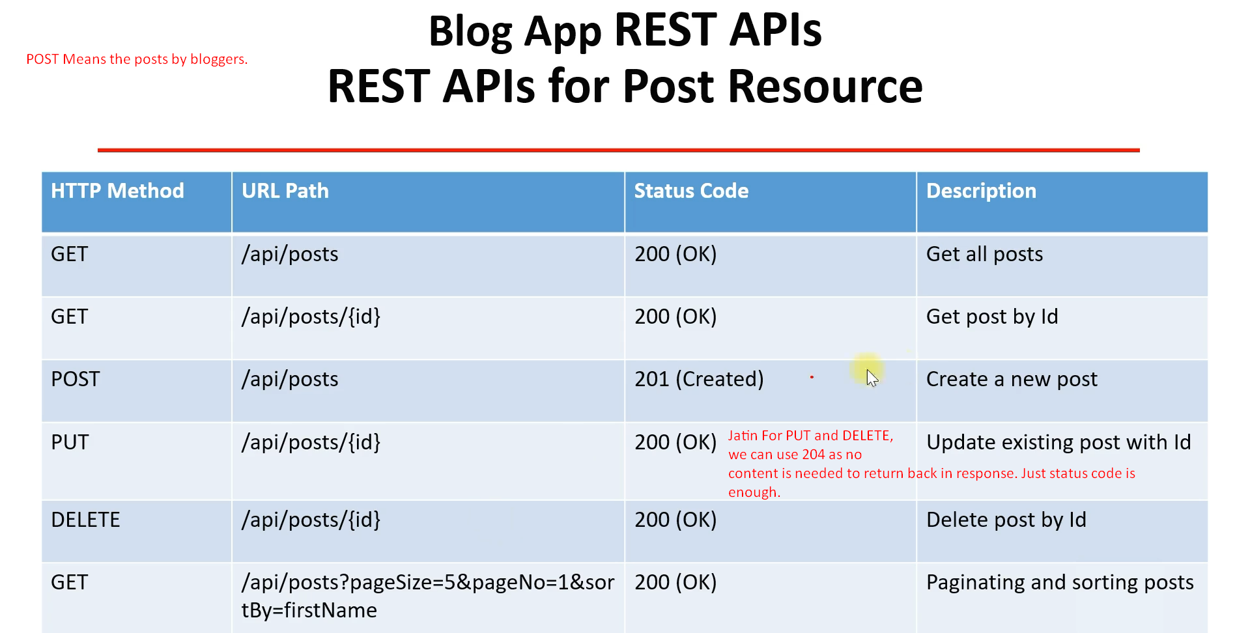
4. **NOTE**: We can add some more columns in the above table like
   1. Request Format.
   2. Response Format.
   3. Media Type for each REST API.